 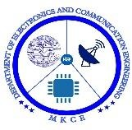 

**POWER EFFICIENT MINI INVERTER**

A Minor Project Report

**Submitted By**

|  |  |
| --- | --- |
| **PAVITHRA T** | **927621BEC144** |
| **POOJA SHREE M** | **927621BEC146** |
| **POORVAJA V S** | **927621BEC147** |
| **PRAVEENA M** | **927621BEC152** |

### BACHELOR OF ENGINEERING

in

### DEPARTMENTOF ELECTRONICS AND COMMUNICATION ENGINEERING

**M.KUMARASAMY COLLEGE OF ENGINEERING**

(Autonomous)

### KARUR – 639 113

**DECEMBER 2022**

# M.KUMARASAMY COLLEGE OF ENGINEERING, KARUR

### BONAFIDE CERTIFICATE

Certified that this project report “POWER EFFICIENT MINI INVERTER” is the Bonafide work of “**PAVITHRA T** (**927621BEC144**), **POOJA SHREE M** (**927621BEC146**), **POORVAJA V S** (**927621BEC147**), **PRAVEENA M** (**927621BEC152**)” who carried out project work under my supervision in the academic year 2022-2023.

|  |  |
| --- | --- |
| **SIGNATURE** | **SIGNATURE** |
| Dr.S.PALANIVELRAJAN, M.E., Ph.D., | Dr.A.KAVITHA, ME.,Ph.D., |
| **HEAD OF THE DEPARTMENT,** | **SUPERVISOR,** |
| Professor, | Professor, |
| Department of Electronics and | Department of Electronics and |
| Communication Engineering, | Communication Engineering, |
| M.Kumarasamy College of Engineering, | M.Kumarasamy College of Engineering, |
| Thalavapalayam, Karur-639113. | Thalavapalayam, Karur-639113. |

This Minor project-I report has been submitted for the **18ECP103L – Minor Project-I**

Review held at M.Kumarasamy College of Engineering, Karur on _________

**PROJECT COORDINATOR**

**Vision of the Institution**

To emerge as a leader among the top institutions in the field of technical education

#### Mission of the Institution

**M1:** Produce smart technocrats with empirical knowledge who can surmount the global challenges

**M2:** Create a diverse, fully engaged, learner-centric campus environment to provide quality education to the students

**M3:** Maintain mutually beneficial partnerships with our alumni, industry, and Professional associations Vision of the Department

#### Vision of the Department

To empower the Electronics and Communication Engineering students with emerging technologies, professionalism, innovative research, and social responsibility.

#### Mission of the Department

**M1:** Attain the academic excellence through innovative teaching learning process, research areas & laboratories and Consultancy projects.

**M2:** Inculcate the students in problem solving and lifelong learning ability.

**M3:** Provide entrepreneurial skills and leadership qualities.

**M4:** Render the technical knowledge and skills of faculty members.

#### Program Educational Objectives (PEOs):

**PEO1: Core Competence:** Graduates will have a successful career in academia or industry associated with Electronics and Communication Engineering.

**PEO2: Professionalism:** Graduates will provide feasible solutions for the challenging problems through comprehensive research and innovation in the allied areas of Electronics and Communication Engineering.

**PEO3: Lifelong Learning:** Graduates will contribute to the social needs through lifelong learning, practicing professional ethics and leadership quality.

**Program Outcomes (POs):**

**PO 1: Engineering knowledge:** Apply the knowledge of mathematics, science, engineering fundamentals, and an engineering specialization to the solution of complex engineering problems.

**PO 2: Problem analysis:** Identify, formulate, review research literature, and analyze complex engineering problems reaching substantiated conclusions using first principles of mathematics, natural sciences, and engineering sciences.

**PO 3: Design/development of solutions:** Design solutions for complex engineering problems and design system components or processes that meet the specified needs with appropriate consideration for the public health and safety, and the cultural, societal, and environmental considerations.

**PO 4: Conduct investigations of complex problems:** Use research-based knowledge and research methods including design of experiments, analysis and interpretation of data, and synthesis of the information to provide valid conclusions.

**PO 5: Modern tool usage:** Create, select, and apply appropriate techniques, resources, and modern engineering and IT tools including prediction and modeling to complex engineering activities with an understanding of the limitations.

**PO 6: The engineer and society:** Apply reasoning informed by the contextual knowledge to assess societal, health, safety, legal and cultural issues, and the consequent responsibilities relevant to the professional engineering practice.

**PO 7: Environment and sustainability:** Understand the impact of the professional engineering solutions in societal and environmental contexts, and demonstrate the knowledge of, and need for sustainable development.

**PO 8: Ethics:** Apply ethical principles and commit to professional ethics and responsibilities and norms of the engineering practice.

**PO 9: Individual and teamwork:** Function effectively as an individual, and as a member or leader in diverse teams, and in multidisciplinary settings.

**PO 10: Communication:** Communicate effectively on complex engineering activities with the engineering community and with society at large, such as, being able to comprehend and write effective reports and design documentation, make effective presentations, and give and receive clear instructions.

**PO 11: Project management and finance:** Demonstrate knowledge and understanding of the engineering and management principles and apply these to one’s own work, as a member and leader in a team, to manage projects and in multidisciplinary environments.

**PO 12: Life-long learning:** Recognize the need for and have the preparation and ability to engage in independent and life-long learning in the broadest context of technological change.

#### Program Specific Outcomes (PSOs):

**PSO1:** Applying knowledge in various areas, like Electronics, Communications, Signal processing, VLSI, Embedded systems etc., in the design and implementation of Engineering application.

**PSO2:** Able to solve complex problems in Electronics and Communication Engineering with analytical and managerial skills either independently or in team using latest hardware and software tools to fulfil the industrial expectations

**Program Specific Outcomes:**

**PSO1:** Applying knowledge in various areas, like Electronics, Communications, Signal processing, VLSI, Embedded systems etc., in the design and implementation of Engineering application.

**PSO2:** Able to solve complex problems in Electronics and Communication Engineering with analytical and managerial skills either independently or in team using latest hardware and software tools to fulfil the industrial expectations.

|  |  |
| --- | --- |
| **Abstract** | **Matching with POs, PSOs** |
|  |  |
| Mini inverter,power efficiency,DC power | PO1,PO2,PO3,PO4,PO5,PO6,PO7,PO8,PO9,PO10,PO11,PO12 ,PSO1,PSO2 |

### ABSTRACT

Power electronics device which converts DC power to AC power at required output voltage and frequency level is known as inverter. First of all, This Project aims to produce a 12V DC power supply into 240V AC output, using a Transformer to step up the power. It is also can capable of producing 1000 watt of Output power. An inverter circuit is use to invert the DC energy into AC. This circuit needed to apply to the home electronics equipment. The circuit is to produce sine wave output with low noise with applies up to 220-240 AC. This circuit is at the last stage of the report, we give some suggestion and recommendation about the future development and make it becomes more technology. In the future, we want target to commercialize and go through world market for our project. As we know, every one of it project has their advantage and disadvantage. Beside of that, we have to reduce the entire disadvantage as much as very well, we can to make it useful and easy to use for another people.

### Table of Contents

**CHAPTER No. CONTENTS** **PAGE No.**

INSTITUTION VISION AND MISSION 3

DEPARTMENT VISION AND MISSION 4

DEPARTMENT PEO, PO AND PSO 5

ABSTRACT 7

LIST OF FIGURES 9

LIST OF ABBREVIATIONS 10

1. INTRODUCTION 11
2. LITERATURE REVIEW 12
3. CIRCUIT DIAGRAM 13
4. COMPONENTS
   1. 12V BATTERY 14
   2. TRANSISTOR 15
   3. MOSFET 16
   4. TRANSFORMER 17
5. APPLICATIONS 18
6. RESULT AND DISCUSSION 19
7. CONCLUSION 20
8. REFERENCES 21

**List of Figures**

|  |  |  |
| --- | --- | --- |
| **Figure No** | **Figure Name** | **Page No** |
| 3.1 | Block diagram of proposed method | 13 |
| 4.1 | Power supply | 14 |
| 4.2 | BC548/NPN Transistors | 15 |
| 4.3 | MOSFET IRF540N | 16 |
| 4.4 | Transformers 12-0-12 1 amp | 17 |
| 6.1 | Result of the project | 20 |

**LIST OF ABBREVIATIONS**

|  |  |  |
| --- | --- | --- |
| AC | - | Alternate Current |
| DC | - | Direct Current |
| V | - | Voltage |
| VSI | - | Voltage source inverter |
| CSI | - | Current source Inverter |
| LED |  | Light Emitting Diode |

1. **INTRODUCTION**

In this section, we will be exposed to our research; on what kind of method have been used by us in order to get information and the data for our project that is Inverter single phase. Some theoretical Background about inverter single phase is basically on how the it our self operates and how It could possibly be done. The main components that we have implemented in the construction of inverter single phase will also be provided. This project is can use for the small places, camping area and other a place is same thing it. So, that why we develop this project. By do this project also we can learn many more about a new thing. This report focuses on DC to AC power inverter, which aim to efficiently transform a DC power source to a high voltage AC source similar to power that would be available at an electrical wall outlet. Inverters are used for many applications, as in situations where low voltage DC sources such as batteries, solar panels or fuel cells must be converted so that devices can run off of AC Power. One example of such a situation would be converting electrical power from a car battery to run a laptop, TV or cell phone. The method, in which the low voltage DC power is inverted, is completed in two steps. The first being the conversion of the low voltage DC power to high voltage DC source, and the second step being the conversion of the high DC source to an AC waveform using pulse width modulation. Another method to complete the desired outcome would be to first convert the low voltage DC power to AC, and then use a transformer to boost the voltage to 240 volts. This project focused on the first method described and specifically the transformation of a high voltage DC source into an AC output. Of the different DC-AC inverters on the market. Today there are essentially two different forms of AC output generated modified sine wave, and pure sine wave. A modified sine wave can be seen as more of a square wave than a sine wave, it passes the high DC voltage for specified amounts of time so that the average power and RMS voltage are the same as if it were a sine wave. These devices are able to run more sensitive devices that a modified sine wave may cause damage to Such as: Laser printer, laptop, power tools, digital clocks and medical equipment.

**2.LITERATURE SURVEY**

AC electrical power supply can be used most electronic devices. It will be difficult to use these devices that electric goes off. This problem can be solved by the use of inverter. DC to AC converter known as an inverter. This function of inverter is to Change DC input voltage to a symmetrical AC output voltage of desired magnitude and frequency. There are various kind of watt in the inverter according to P=VI. Watt is dependent on the current. The using of watt gets form transformer, coil wire depending on the ampere. There are various types of inverter and they are classifies according to the No. of the phases. Use of power of semiconductor devices, communication principles and output waveforms. We will first look single phase inverter. Secondly, we will discuss Voltage Source Inverter (VSI) and Current Source Inverter (CSI). Inverter are used many different industrial applications including the speed control of induction and synchronous motors, induction heating, aircraft power supplies, uninterruptible power supplies(UPS) and high voltage DC transmission. Town and countries which have no sufficiently light use inverter. It is an essential device to increase for lives. So, we study inverter and then we can know electrical and electronic knowledge.

**3.BLOCK DIAGRAM (**INVERTER)

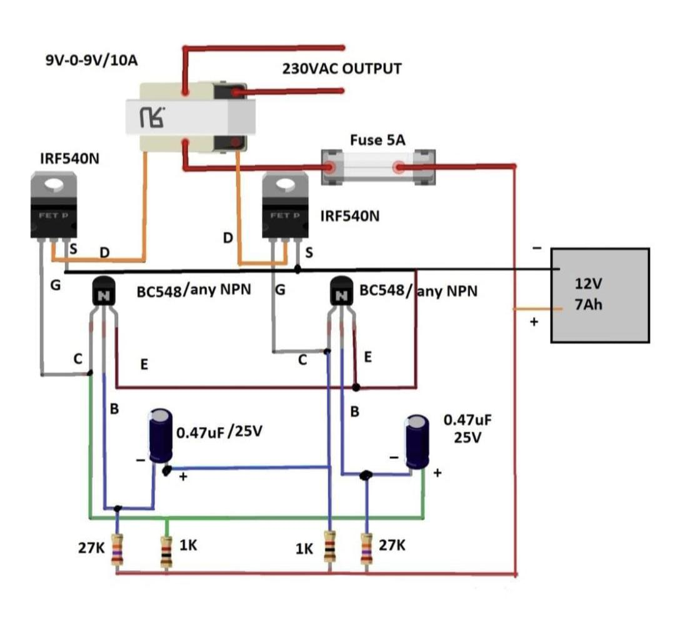

Figure 3.1

**4.COMPONENTS**

**HARDWARE REQUIREMENT**

* BC548 / NPN Transistors
* 27K Ohm
* 1K Ohm
* 0.47uF Capacitor
* MOSFET IRF540N
* Transformers 12-0-12 1 amp
* 12v 7Ah Battery

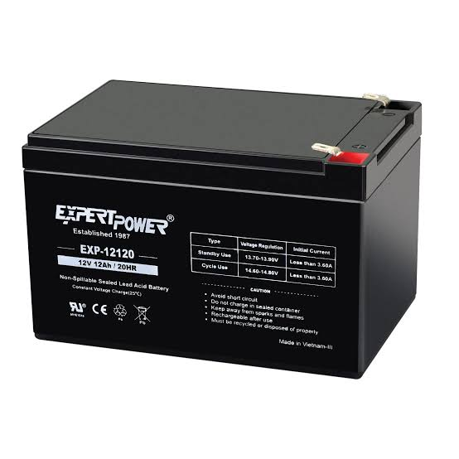**4.1. 12v Battery**

Figure 4.1 12v Battery

The power input for the inverter circuit is from the 12V rechargeable Battery. When 12V rechargeable battery supply is fed to the control circuit through the relay, then the input power to the circuit will be ON. The transistor (TR3) from the circuit with the Light Emitting Diode (LED) display whether the Power from the rechargeable battery to the relax is pass through to circuit or not. If the power is passing through the circuit, the zener diode of 5.1V will apply to Turn on the transistor CRR3 and then pass through and turn ON the LED.

**4.2. BC548/NPN Trans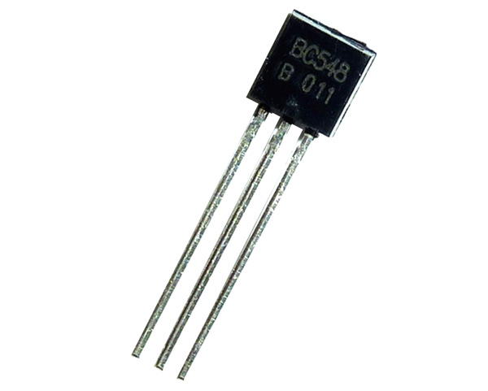istor**

Figure 4.2Transistor BC548/NPN Transistor

BC548 is a NPN transistor so the collector and emitter will be left open (Reverse biased) when the base pin is held at ground and will be closed (Forward biased) when a signal is provided to base pin. BC548 has a gain value of 110 to 800, this value determines the amplification capacity of the transistor. The maximum amount of current that could flow through the collector pin is 500mA, hence we cannot connect loads that consume more than 500mA using this transistor. To bias a transistor we have to supply current to base pin, this current (IB) should be limited to 5mA.When this transistor is fully biased, it can allow a maximum of 500mA to flow across the collector and emitter. This stage is called Saturation region and the typical voltage allowed across the Collector-Emitter (V­CE) or Base-Emitter (VBE) could be 200 and 900 mV respectively. When base current is removed the transistor becomes fully off, this stage is called as the Cut-off Region and the Base Emitter voltage could be around 660 mV.

**4.3. MOSFET IRF540N**

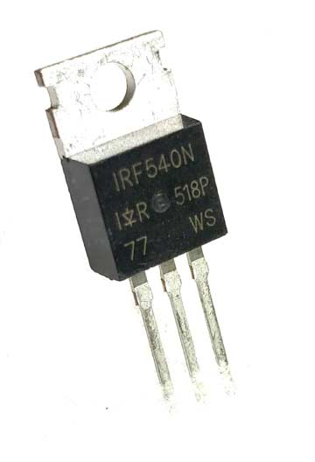

Figure 4.3 MOSFET IRF540 N

The IRF540N is an n-Channel MOSFET. This MOSFET can drive loads up to 23A and can support peak current up to 110A. It also has a threshold voltage of 4V, which means it can easily driven by low voltages like 5V. Hence it is mostly used with Arduino and other microcontrollers for logic switching. Speed control of motors and light dimmers are also possible with this MOSFET since it has good switching characteristics.

**4.4.Transformers 12-0-12 1 amp**

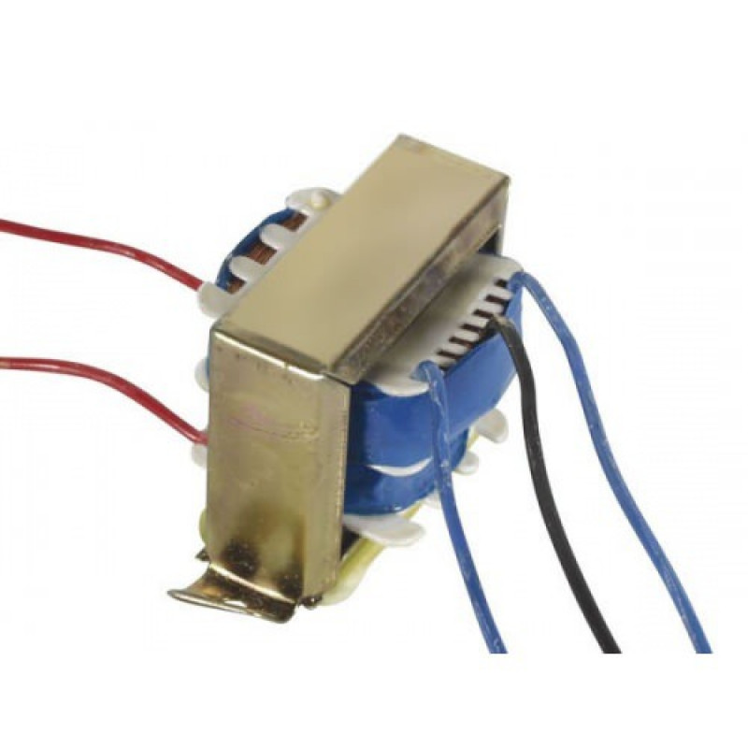 Figure 4.4 Transformer 12-0-12 1 amp

12-0-12 1A Center Tapped Step Down Transformer is a general purpose chassis mounting mains transformer. Transformer has 230V primary winding and center tapped secondary winding. The transformer has flying colored insulated connecting leads The Transformer act as step down transformer reducing AC - 230V to AC - 12V.The Transformer gives outputs of 12V, 12V and 0V.

**5.APPLICATIONS**

Power inverters are used today for many tasks like powering appliances in a car such as cell phones, radios and televisions. They also come in handy for consumers who own camping vehicles, boats and at constructing sites where an electric grid may not be as accessible to hook into. Inverters Allow the user to provide AC power in areas where only batteries can be made available, allowing portability and freeing the user of long power cords. On the market today are two different types of power inverters, modified sine wave and pure sine wave generators. These inverters differ in their puts, providing varying levels of efficiency and distortion that can affect electrons devices in different ways. A modified sine wave is similar to a square wave but instead has a “stepping” look to it that relates more in shape to a sine wave. The waveform is easy to produce because it is just the produce of the product of switching between 3 values at set frequencies, thereby leaving out the more complicated circuitry needed for a pure sine wave. The modified sine wave inverter provides a cheap and easy solution to powering devices that need AC power. It does have some drawbacks as not all devices work properly on a modified sine-wave, products such as computer and medical equipment are not resistance to the distortion of the signal and must be run off a pure sine wave power source.

**6.RESULT AND DISCUSSION**

In this project, we have tried to convert 12V DC to 220V AC by using 12-0-12 amp transformer and 12V battery and other passive components.

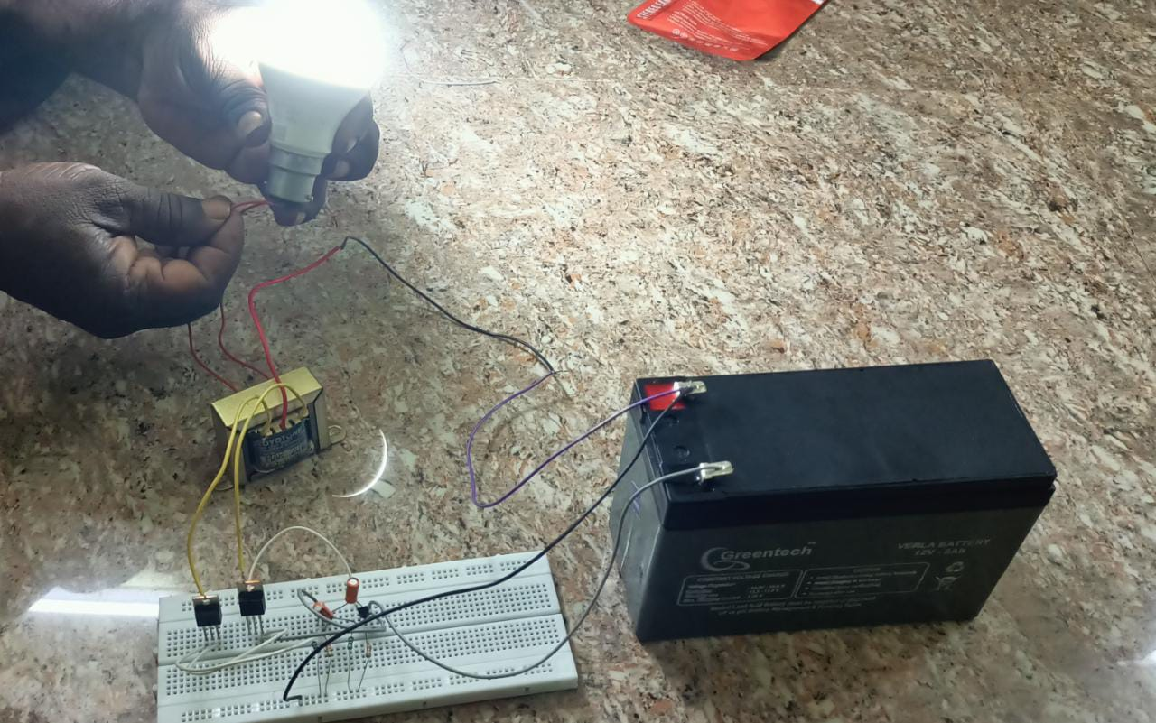

Figure: 6.1 Result of the Project

This is the outcome of our project.

**7.CONCLUSION**

The first to create this project, we search all about already existing Inverter systems in world. For an example an inverter is an electrical device that converts direct current (DC) to alternating current (AC), the converted AC can be at any required voltage and frequency with the use of appropriate transformers, switching, and control circuits. Solid-state inverters have no moving parts and are used in a wide range of applications, from small switching power supplies in computers, to large electric utility high-voltage direct current applications that transport bulk power. Inverters are commonly used to supply AC power from DC sources such as solar panels or batteries. The inverter performs the opposite function of a rectifier. The major skill or we are learning about this project is inverter to generates the outputs supply and get the output voltage. What we get from this is electronic soldering and wiring, single phase wiring circuits in connection, size cable use.

**7.REFERENCES**

1. [1] Kang Miao, Bidirectional battery charger for electric vehicles, Asia (ISGT Asia) 2018. • [2] Pinto, J. G. Bidirectional battery charger with Grid-to-vehicle, Vehicle -to-Grid and Vehicle-to- Home technologies, IEEE 2020.
2. Bugatha Ram vara prasad, “Solar Powered BLDC Motor with HCC Fed Water Pumping System for Irrigation,” Int. J. Res. Appl. Sci. Eng. Technol., vol. 7, no. 3, pp. 788–796, 2019, doi: 10.22214/ijraset.2019.3137.
3. Ulrich and J. borenstein. 1998. VFH+: Reliable obstacle avoidance for fast mobile robots. Proceedings of the 1998 IEEE Conference on Robotics and Automation. pp. 1572-1577.
4. L. Navarro-Serment, C. Paredis and P. Khosla. 1999. A beacon system for the localization of distributed robotic teams. Proceedings of the International Conference on Field and Service Robotics. pp. 232- 237.
5. T. Bailey, E. Nebot, J. Rosenblatt and H DurrantWhyte. 1999. Robust distinctive place recognition for topological maps. Proceedings of the International Conference on Field and Service Robotics. pp. 347- 352.
6. Gallardo-Lozano, Milanes-Monster, Guerrero- Martinez, Three-phase bidirectional battery charger for smart electric vehicles, International Conference-Workshop 2021. M. C. Kisacikoglu, “Vehicle-to-grid (V2G) reactive power operation analysis of the EV/PHEV bidirectional battery charger,” Ph.D. dissertation, University of Tennessee, Knoxville, 2019.

# 

# 

# 

# 

# 

# 

# 

# 